Background Generator

The background layer shows when there is nothing to display from the layers above. There are 16 named background generators in libPAWS. The result of the individual background generators are shown in the table below.

Result of set_background( PURPLE, ORANGE, value from table );
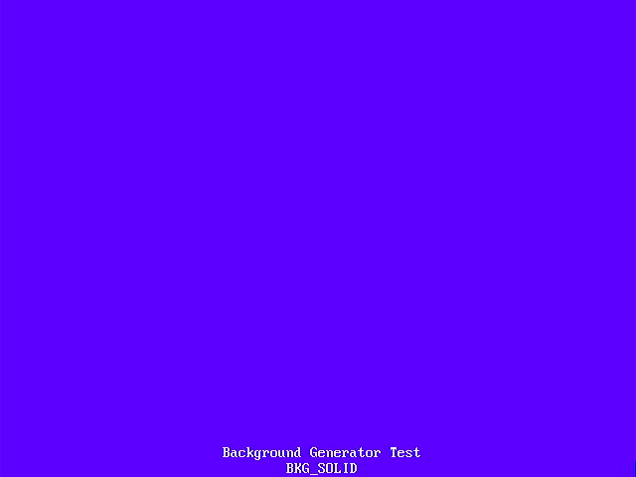  BKG_SOLID | 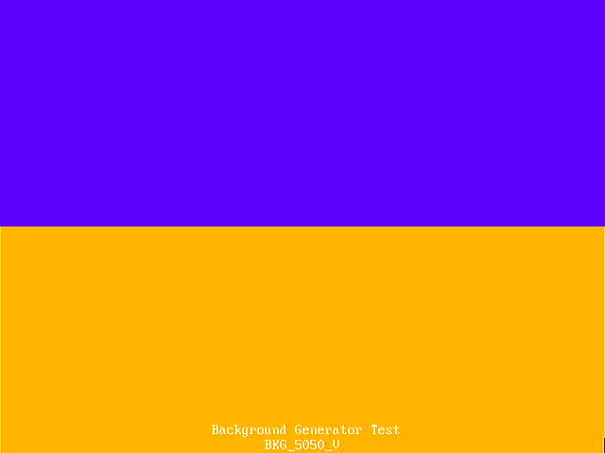  BKG_5050_V | 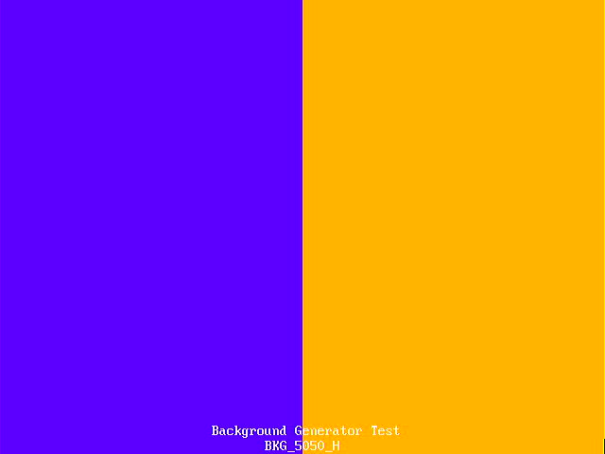  BKG_5050_H | 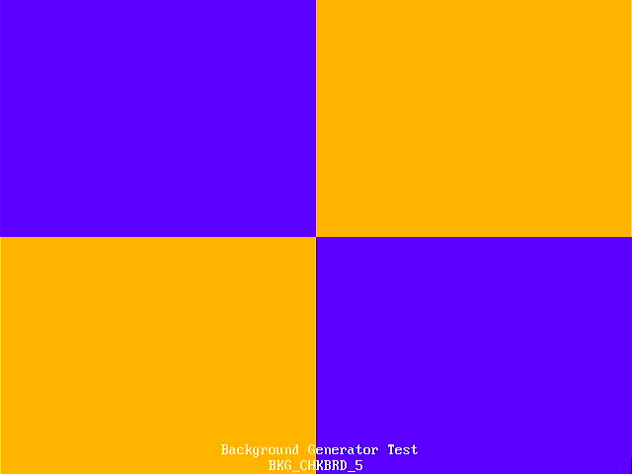  BKG_CHKBRD_5
  BKG_RAINBOW | 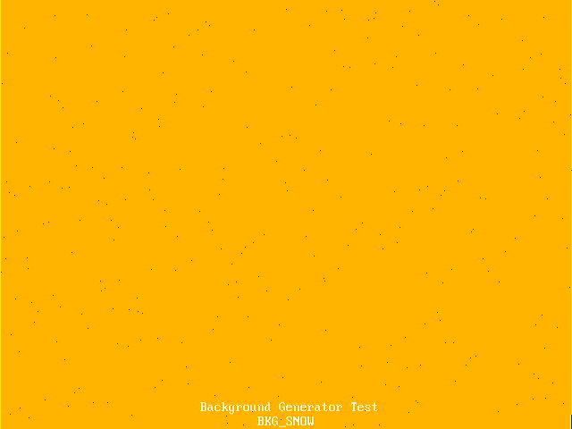  BKG_SNOW |   BKG_STATIC | 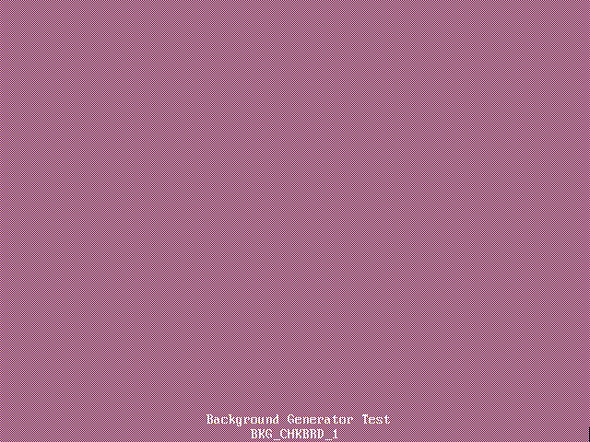  BKG_CHKBRD_1
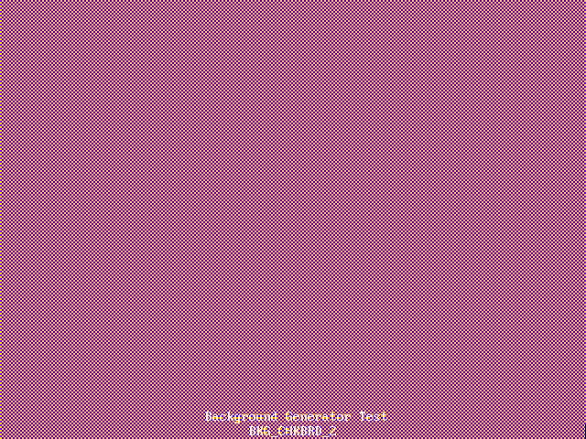  BKG_CHKBRD_2 |   BKG_CHKBRD_3 |   BKG_CHKBRD_4 | 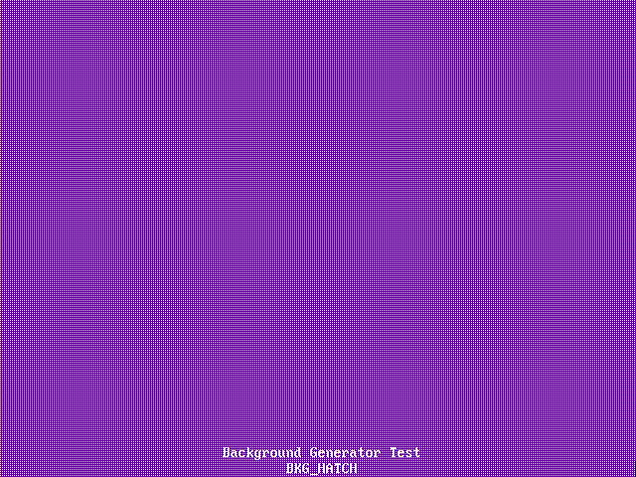  BKG_HATCH
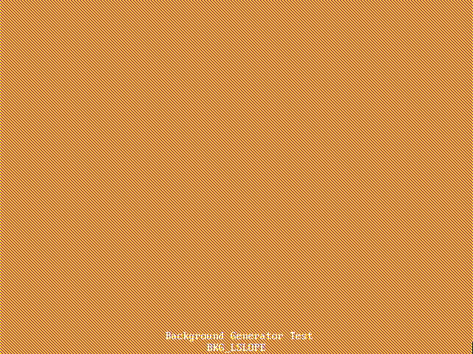  BKG_LSLOPE | 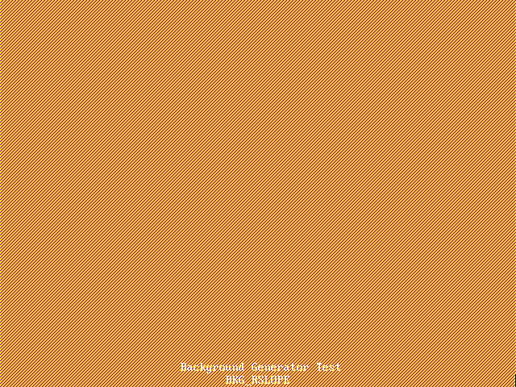  BKG_RSLOPE | 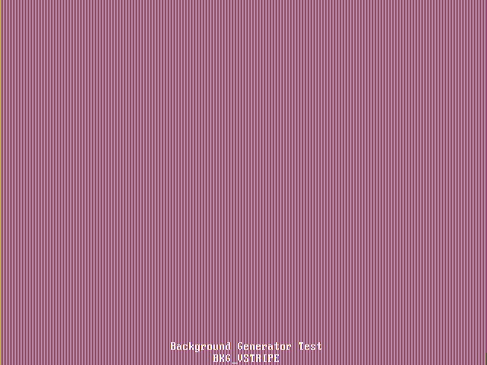  BKG_VSTRIPE | 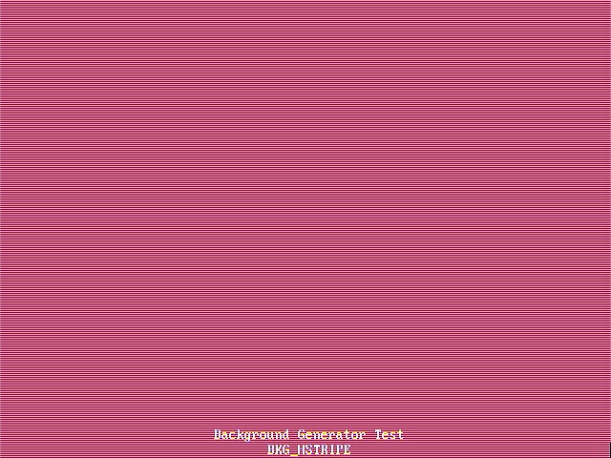  BKG_HSTRIPE

In addition, a simple co-processor, called COPPER, is available to change background generator parameters during the frame generation.

Background COPPER Programming (New Copper NuCu)

The COPPER is designed to allow the changing of the background generator parameters during the display frame, referred to as NuCU.

NuCu has 4 registers for data storage, and 4 psuedo registers; when reading giving access to the pixel coordinates and vblank status; when writing setting the background generator parameters; plus a CPU read/write value accessible.

READ |  | WRITE
CU_RB | VBLANK status | CU_BM | Background MODE
CU_RX | X pixel coordinate | CU_BC | Background COLOUR
CU_RY | Y pixel coordinate | CU_BA | Background ALT COLOUR
CU_RC | CPU input value | CU_RC | CPU output value
CU_R0 | Register 0 | CU_R0 | Register 0
CU_R1 | Register 1 | CU_R1 | Register 1
CU_R2 | Register 2 | CU_R2 | Register 2
CU_R3 | Register 3 | CU_R3 | Register 3
In the instruction table below, REG1 refers to both the destination register AND the first operand for two register operations. (X) would refer to the value of the X register.

The REG2/LITERAL flag is set to CU_RL to specify a literal value, or CU_RR to specify the contents of the register. See the example programs.

NuCu has 8 memory locations, which can be set by the CPU before the NuCu program starts running. These can be read by the LFM instruction, and set by the STM instruction in the NuCu program.

NuCu has program storage for 128 entries, an 8 entry RSTACK for calling/returning from subroutines, and an 8 entry DSTACK for saving and loading registers. These values can be reconfigured at build time to allow for more program space, memory or larger stacks.

NuCu has a fixed instruction set, with 4 fields as detailed below.

OPCODE | DEST REG AND  REG1 | REG2 REG /  LITERAL FLAG | REG2 /  LITERAL | EXAMPLE | MEANING
CU_JPL |  |  |  | JPL 7 | JUMP to LI
CU_JPR |  |  | R | JPR (R0) | JUMP to (reg2)
CU_JSL |  |  |  | JSL 7 | Jump to subroutine at LI
CU_JSR |  |  | R | JSR (R0) | Jump to subroutine at (reg2)
CU_RET |  |  |  | RET | Return from subroutine
CU_SLI |  |  |  | SLI 7 | Save LI to the data stack ( literal only )
CU_SRx |  |  |  | SR0 | Save (Rx) to the data stack
CU_LRx |  |  |  | LR0 | Load Rx from the data stack
CU_SET | Y | Y | Y | SET R1 ← (R0) | SET reg1 to RL
CU_ADD | Y | Y | Y | ADD R0 ← (R0) + 1 | ADD RL to (reg1) store in reg1
CU_SUB | Y | Y | Y | SUB R0 ← (R0) - 1 | SUB RL from (reg1) store in reg1
CU_AND | Y | Y | Y | AND R0 ← (R0) & 7 | AND (reg1) by RL store in reg1
CU_OR | Y | Y | Y | OR R0 ← (R0) | 1 | OR (reg1) by RL store in reg1
CU_XOR | Y | Y | Y | XOR R0 ← (R0) ^ 1 | XOR (reg1) by RL store in reg1
CU_SHL | Y | Y | Y | SHL (R0) ← (R0) << 6 | Shift Left (reg1) by RL store in reg1
CU_SHR | Y | Y | Y | SHR (R0) ← (R0) >> 1 | Shift Right (reg1) by RL store in reg1
CU_SEQ | Y | Y | Y | SEQ (R0) == (Y) | Skip next if (reg1) == RL
CU_SNE | Y | Y | Y | SNE (R0) == (X) | Skip next if (reg1) != RL
CU_SLT | Y | Y | Y | SLT (R0) < (R1) | Skip next if (reg1) < RL
CU_SLE | Y | Y | Y | SLE (R0) <= (R1) | Skip next if (reg1) <= RL
CU_RND | Y | Y | Y | SET R0 ← RAND & (R1) | SET reg1 to RANDOM & RL
CU_LFM | Y | Y | Y | LFM R0 ← [ (R1) ] | LOAD [ RL ] store in reg1
CU_STM | Y | Y | Y | STM [ 2 ] ← (R1) | STORE reg1 in [ RL ]
Rx refers to one of the registers R0, R1, R2 or R3 for save/load data stack instructions.
(reg) refers to value of the register.
[ addr ] refers directly to contents of a memory cell.
[ (reg) ] refers to the cotents of a memory cell identified by the value of the register.
LI refers to literal value.
RL refers to (reg2) or literal value depending on the reg2/literal flag.
SKIP instructions act like CHIP8 and bypass the following instruction if the condition is true.

Sample NuCu Program

A simple NUCU program that sets the background generator to the BKG_SNOW pattern on a BLACK background, and changes the colour of the snow/stars every 64 pixels down the screen to give a rainbow effect.
copper_startstop( 0 ); // STOP THE COPPER FROM RUNNING

unsigned short memoryinit[8] = {
WHITE,
RED,
ORANGE,
YELLOW,
GREEN,
LTBLUE,
PURPLE,
MAGENTA
};

copper_set_memory( memoryinit ); // PROGRAM COPPER MEMORY ARRAY OF COLOURS

copper_program( 0, CU_SET, CU_BM, CU_RL, BKG_SNOW ); // BACKGROUND SNOW GENERATOR
copper_program( 1, CU_SET, CU_BA, CU_RL, BLACK ); // BACKGROUND ALT BLACK
copper_program( 2, CU_SET, CU_BC, CU_RL, WHITE ); // BACKGROUND WHITE

copper_program( 3, CU_SET, CU_R0, CU_RL, 0 ); // SET R0 = 0

copper_program( 4, CU_SET, CU_R1, CU_RR, CU_R0 ); // SET R1 = R0
copper_program( 5, CU_SHL, CU_R1, CU_RL, 6 ); // R1 = R1 * 64
copper_program( 6, CU_LFM, CU_R2, CU_RR, CU_R0 ); // R2 = MEM[ (R0) ]

copper_program( 7, CU_SEQ, CU_RY, CU_RR, CU_R1 ); // Y == R1 ?
copper_program( 8, CU_JPL, FALSE, CU_RL, 7 ); // SKIP YES, ELSE GO TO 7

copper_program( 9, CU_SET, CU_BC, CU_RR, CU_R2 ); // SET BACKGROUND = R2
copper_program( 10, CU_ADD, CU_R0, CU_RL, 1 ); // R0 = R0 + 1
copper_program( 11, CU_AND, CU_R0, CU_RL, 7 ); // R0 = R0 & 7
copper_program( 12, CU_JPL, 4 ); // JUMP 4

copper_startstop( 1 ); // START THE COPPER
See ASTROIDS / INVADERS / DEMO for this NuCu program running.

NuCu runs at 25MHz which matches the video clock. Each instruction takes 1 cycle, equivalent to 1 pixel.

It should be noted that RX and RY refer to the pixel to be displayed NEXT or during this cycle, RX never goes out of the range 0-639, and RY never goes out of the range 0-479.

If VBLANK or HBLANK, RX will be 0, the next pixel to be displayed on the line.

If VBLANK, RY will be 0, the next line to be displayed, and if HBLANK, RY will the value of the next line to be drawn.

Example screenshots of NuCu Programs:

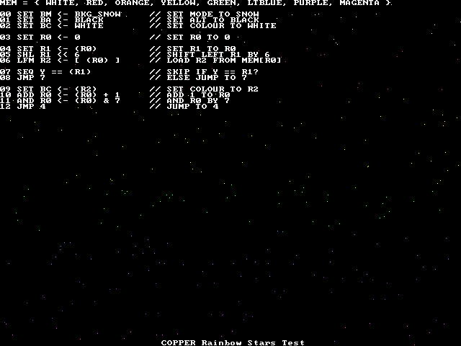 | 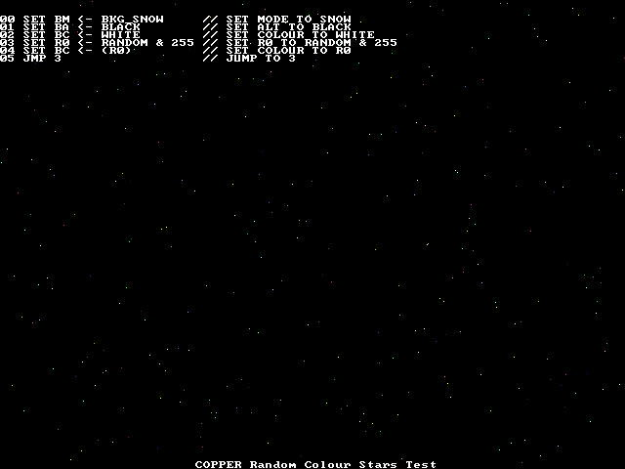
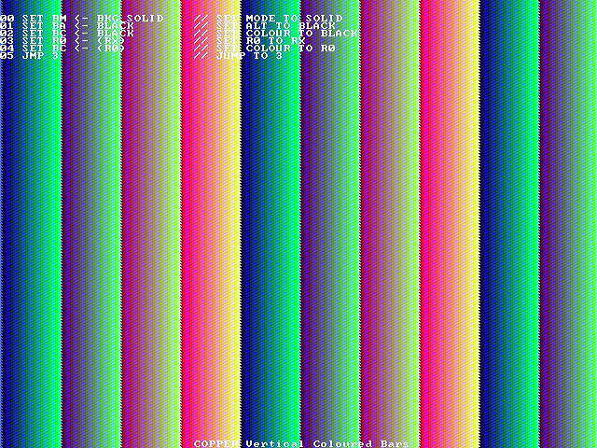 | 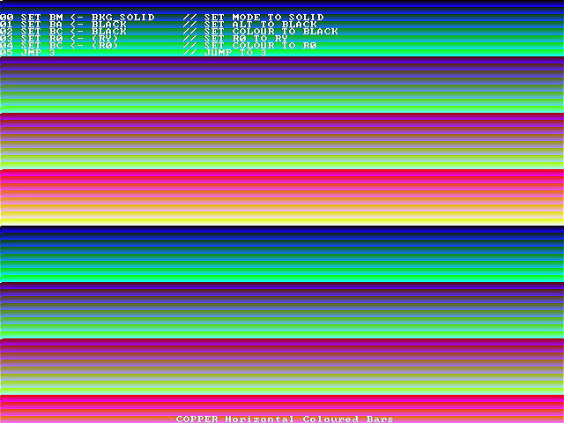

The following PAWSlibrary functions are used to control the background generator and NuCU..

Function | Description
void set_background( unsigned char colour, unsigned char altcolour, unsigned char backgroundmode ) | STOP NuCu and set the background generator parameters directly.
void copper_startstop( unsigned char status ) | TRUE will start NuCu, FALSE will stop NuCu.
void copper_set_memory( unsigned short *memory ) | Upload an array of 8 10-bit numbers to the NuCu memory. These can only be uploaded whilst NuCu is not running.
void copper_program( unsigned char address, unsigned char command, unsigned char reg1, unsigned char flag, unsigned short reg2 ) | Set the program entry at address (0-127) to the opcode command; using reg1 as the destination and source for the first register; flag as the reg2/literal flag; reg2 as the register identifier or literal value.
void set_copper_cpuinput( unsigned short value ) | Set the NuCu CPU input value.
unsigned short get_copper_cpuoutput( void ) | Read the NuCu CPU output value.

